**1.Get me the IP address of a particular domain (guvi.in)**

**Command Used** : nslookup guvi.in | host guvi.in

**IP address of Guvi.in** : 172.67.70.207

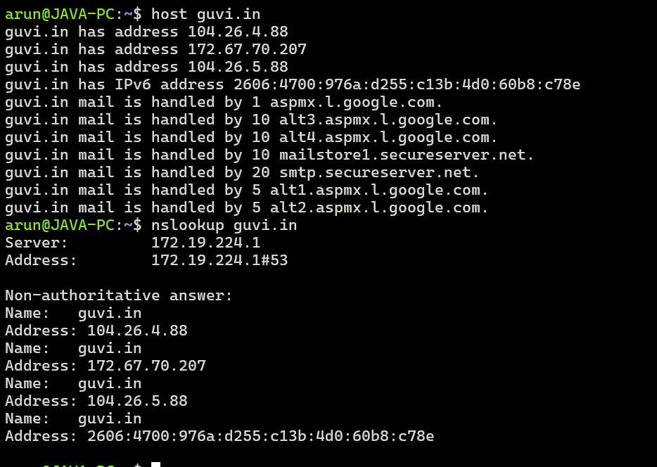

**2. How do I find the CPU/memory usage of my server?**

**Command Used** :   
**top** - to view current usage / statistics of machine resources

**free -h** – to view how much free resources available ; -h – human readable format

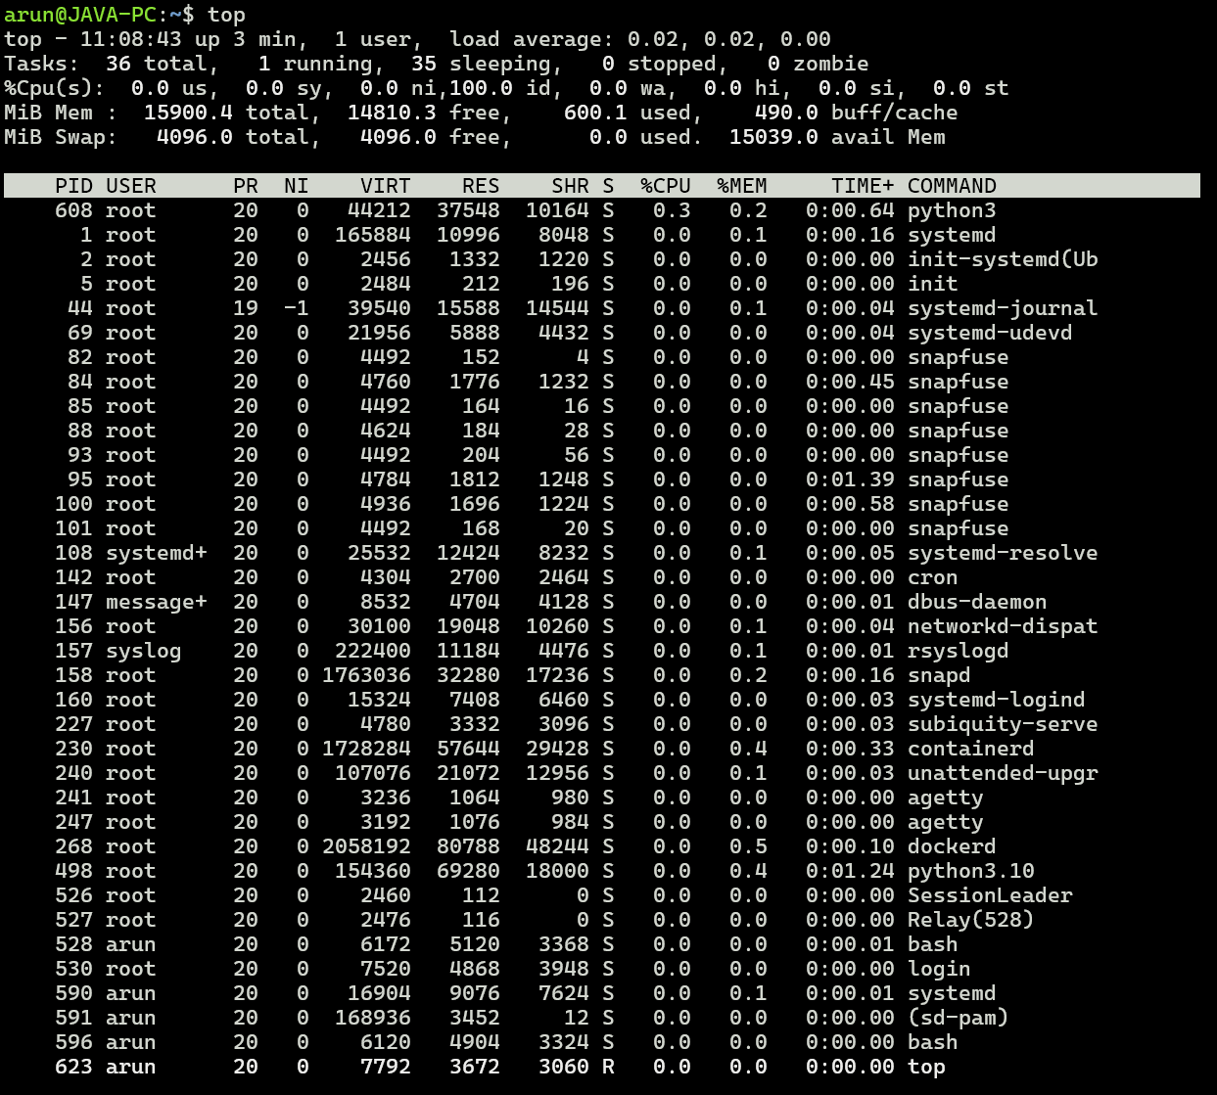



**3. Test the connectivity between 2 nodes.**

**Command Used** : ping <domain name / IP address>

